Test Case: tc003_SPX_Dev5_Crear_Requisicion_Spot_Tipo_Cobro_CC_Urgent
Step 1 - Enter username and password and click to button Enter : Credentials Entered
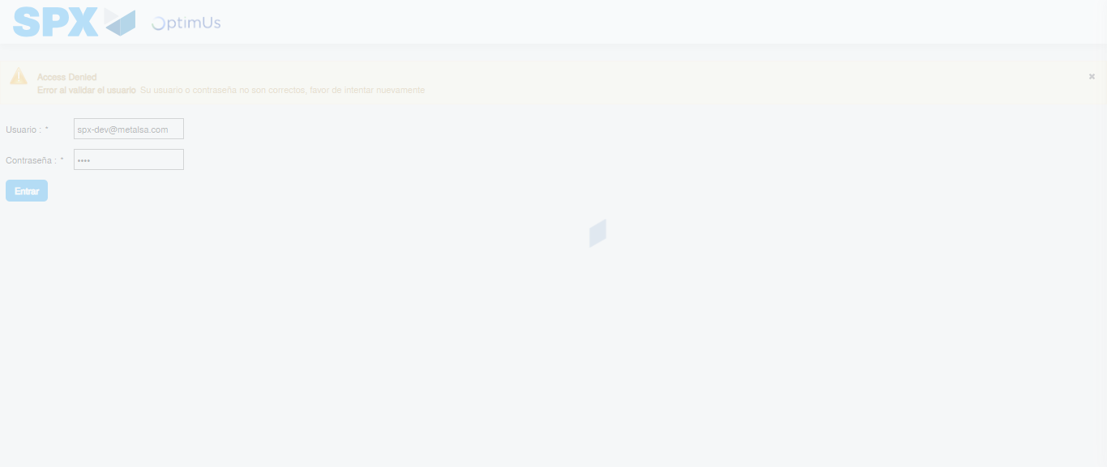Image file-name: QC_Testing-tc003_SPX_Dev5_Crear_Requisicion_Spot_Tipo_Cobro_CC_Urgent-1782242433696

Step 2 - Select to UEN and Access to Spot Buy Requisitions : UEN Correctly selected and Correct access
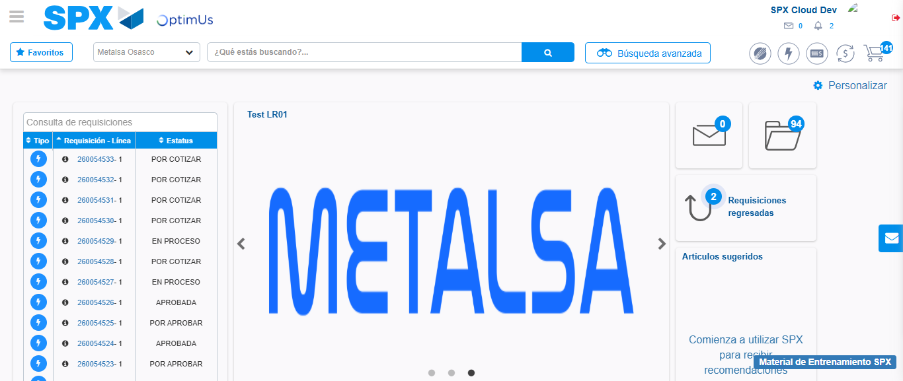Image file-name: QC_Testing-tc003_SPX_Dev5_Crear_Requisicion_Spot_Tipo_Cobro_CC_Urgent-1782242503654

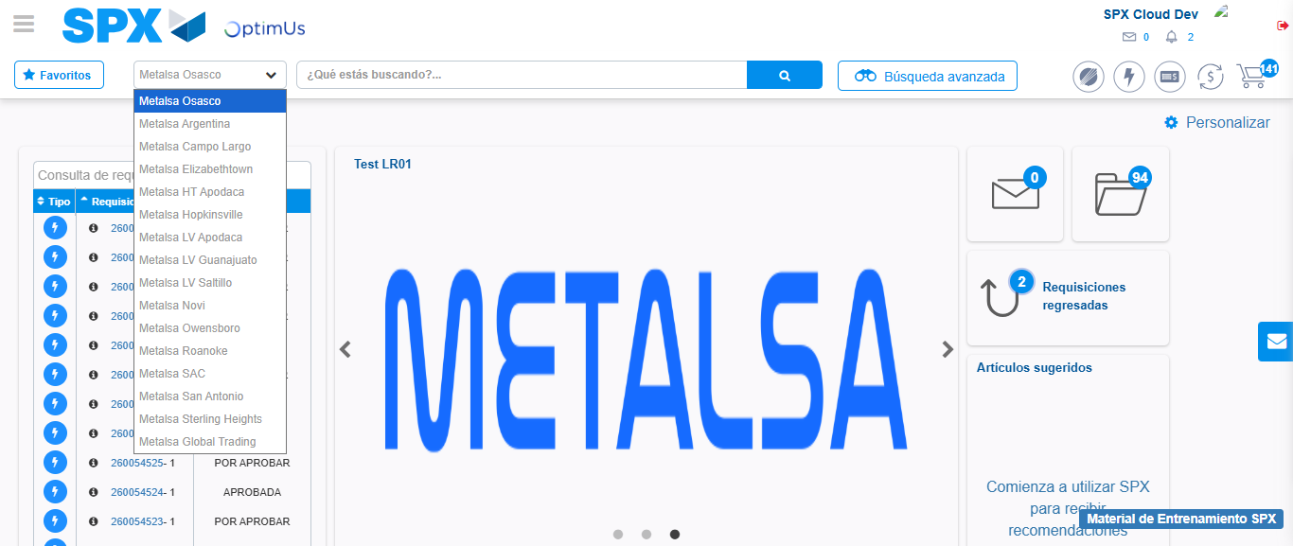Image file-name: QC_Testing-tc003_SPX_Dev5_Crear_Requisicion_Spot_Tipo_Cobro_CC_Urgent-1782242506429

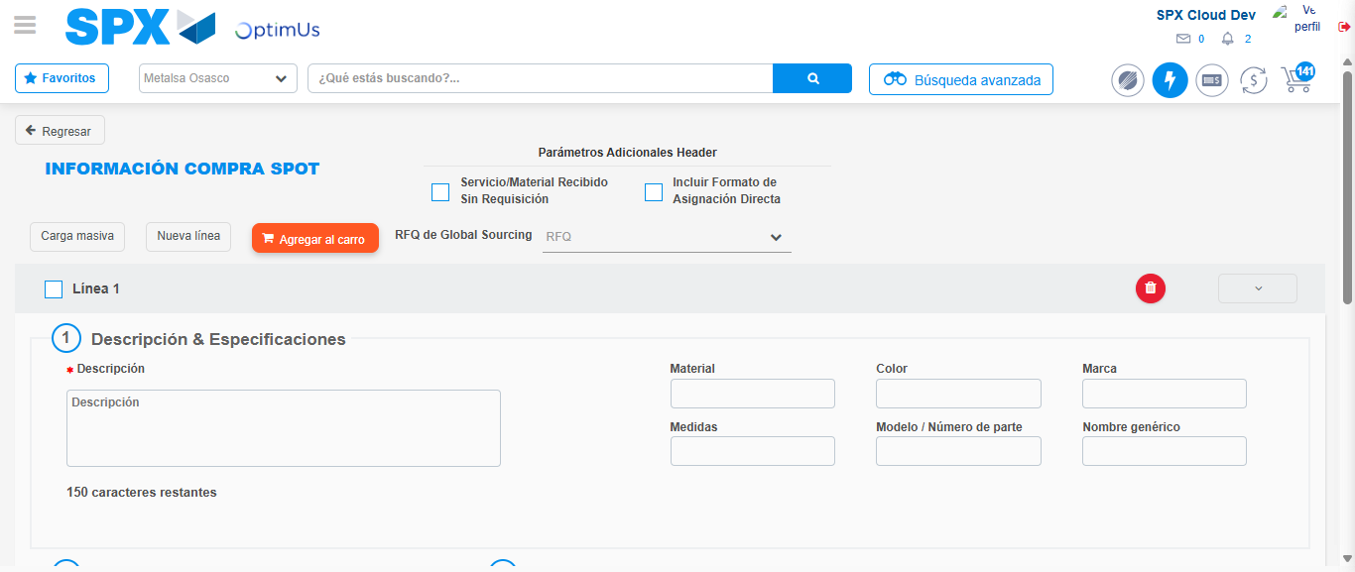Image file-name: QC_Testing-tc003_SPX_Dev5_Crear_Requisicion_Spot_Tipo_Cobro_CC_Urgent-1782242524950

Step 3 - Data Capture Spot Buy Requisition: Data captured correctly
Image file-name: QC_Testing-tc003_SPX_Dev5_Crear_Requisicion_Spot_Tipo_Cobro_CC_Urgent-1782242525273

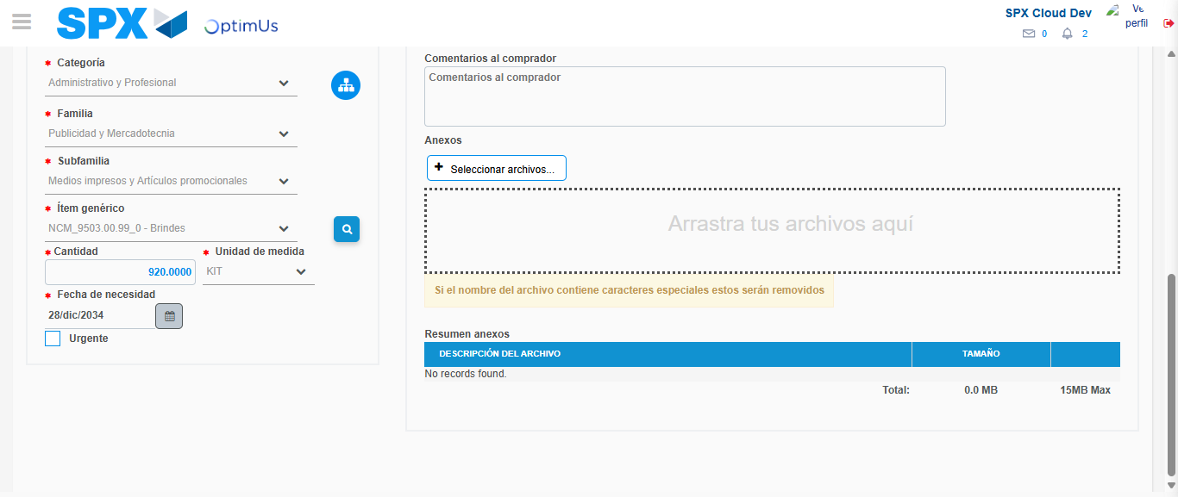Image file-name: QC_Testing-tc003_SPX_Dev5_Crear_Requisicion_Spot_Tipo_Cobro_CC_Urgent-1782242540260

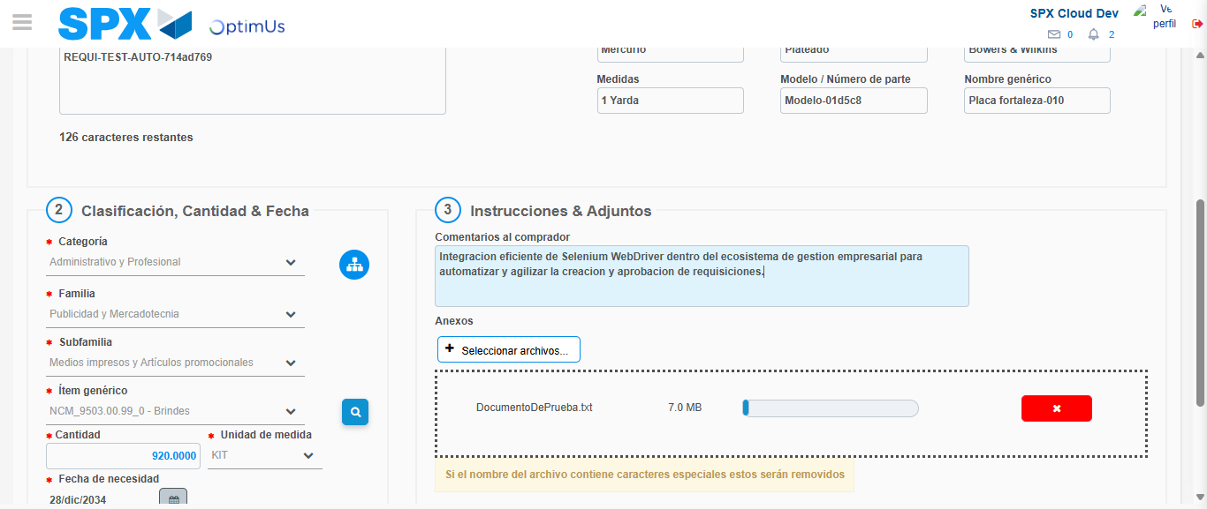Image file-name: QC_Testing-tc003_SPX_Dev5_Crear_Requisicion_Spot_Tipo_Cobro_CC_Urgent-1782242541180

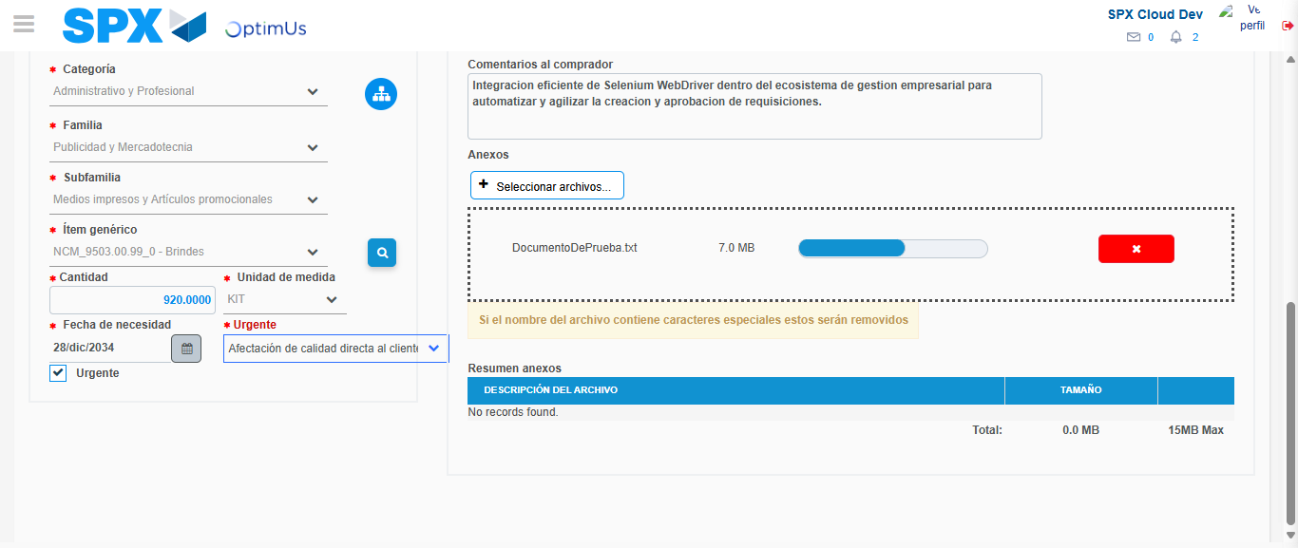Image file-name: QC_Testing-tc003_SPX_Dev5_Crear_Requisicion_Spot_Tipo_Cobro_CC_Urgent-1782242545098

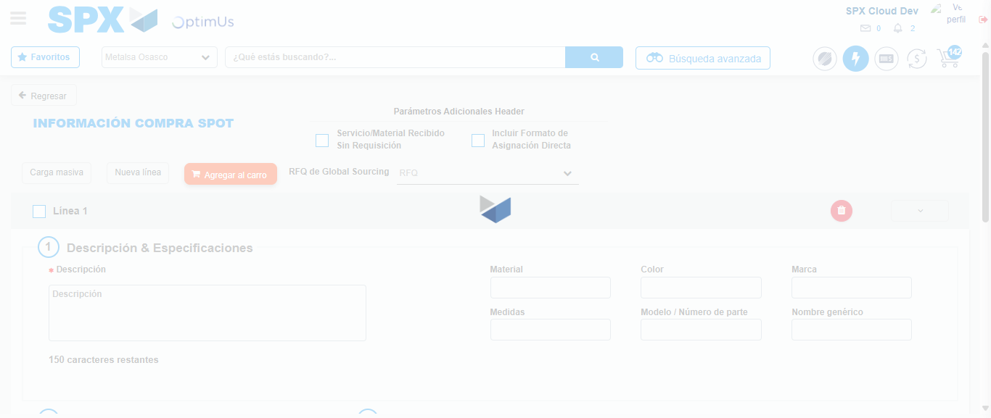Image file-name: QC_Testing-tc003_SPX_Dev5_Crear_Requisicion_Spot_Tipo_Cobro_CC_Urgent-1782242548195

Step 7 - Return to Main Page SPX : Return to Main Page SPX
Image file-name: QC_Testing-tc003_SPX_Dev5_Crear_Requisicion_Spot_Tipo_Cobro_CC_Urgent-1782242503654

Image file-name: QC_Testing-tc003_SPX_Dev5_Crear_Requisicion_Spot_Tipo_Cobro_CC_Urgent-1782242506429

Image file-name: QC_Testing-tc003_SPX_Dev5_Crear_Requisicion_Spot_Tipo_Cobro_CC_Urgent-1782242524950

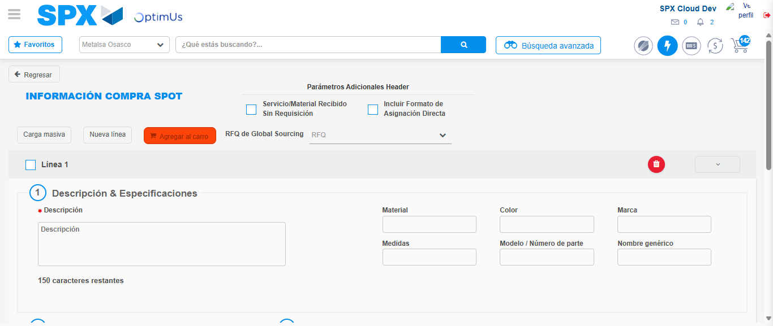Image file-name: QC_Testing-tc003_SPX_Dev5_Crear_Requisicion_Spot_Tipo_Cobro_CC_Urgent-1782242550485

Image file-name: QC_Testing-tc003_SPX_Dev5_Crear_Requisicion_Spot_Tipo_Cobro_CC_Urgent-1782242550696

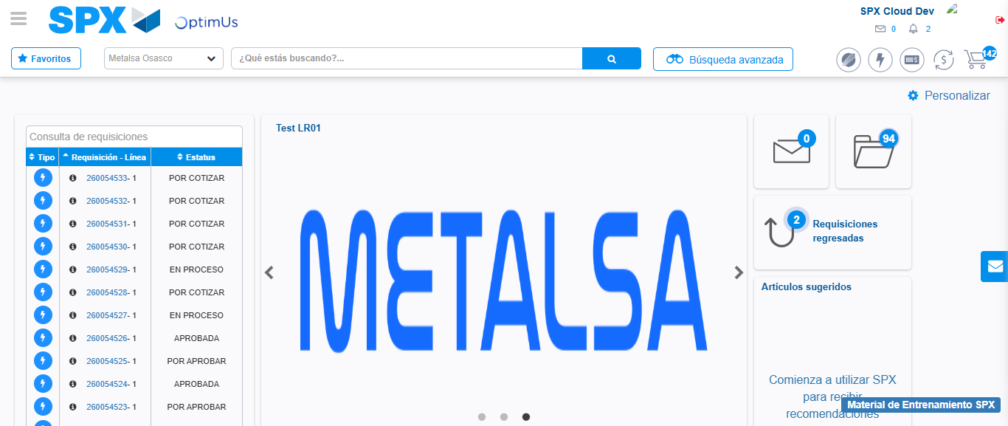Image file-name: QC_Testing-tc003_SPX_Dev5_Crear_Requisicion_Spot_Tipo_Cobro_CC_Urgent-1782242572587

Step 8 - Log Out : Log Out SPX
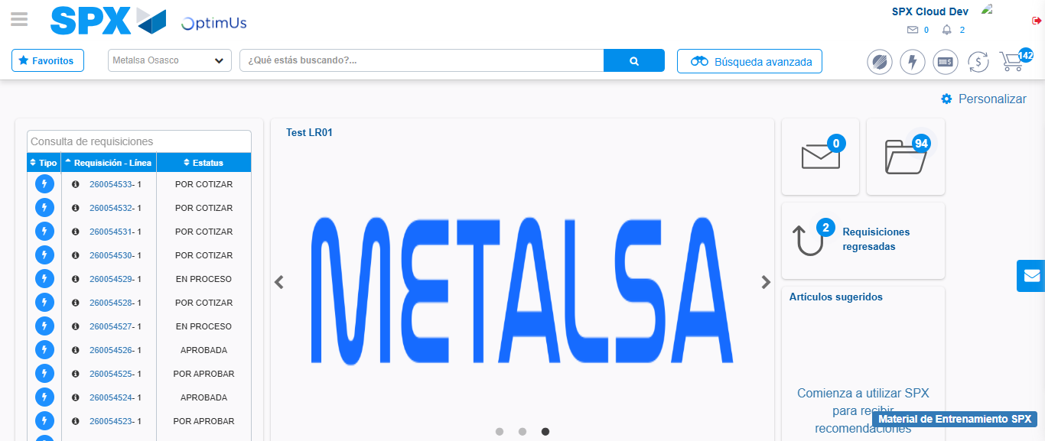Image file-name: QC_Testing-tc003_SPX_Dev5_Crear_Requisicion_Spot_Tipo_Cobro_CC_Urgent-1782242572922

